Customer Crisis Analysis:

codebasics.io
Problem Statement
Provide Insights for a Crisis Recovery to an Online Food Delivery Startup
Domain: Food Delivery & Consumer Analytics Function: Crisis Recovery
& Business Strategy
QuickBite Express is a Bengaluru-based food-tech startup (founded in 2020) that connects
customers with nearby restaurants and cloud kitchens.
In June 2025, QuickBite faced a major crisis. A viral social media incident involving food
safety violations at partner restaurants, combined with a week-long delivery outage during
the monsoon season, triggered massive customer backlash. Competitors capitalized with
aggressive campaigns, worsening the situation.
The challenges were severe:
• A large portion of active users disengaged within a short period.
• Daily orders saw a sharp decline compared to earlier months.
• Customer satisfaction scores fell sharply, signaling trust issues.
• Many partner restaurants shifted to competing platforms.
• Customer acquisition costs rose significantly.
QuickBite has allocated a major recovery budget, overhauled food safety protocols, and
upgraded its delivery infrastructure.
The management expects detailed insights into the following:
1. Customer Segments: Identify which customers can be recovered and which need new
strategies.
2. Order Patterns: Analyse order trends to uncover behavioral changes across phases
(pre-crisis, crisis, recovery).
3. Delivery Performance: Assess delivery times, cancellations, and SLA compliance to
pinpoint operational gaps.
4. Campaign Opportunities: Recommend targeted initiatives to rebuild trust and loyalty
across demographics.
5. Restaurant Partnerships: Predict which partnerships are most valuable for long-term
retention.
6. Feedback & Sentiment: Monitor real-time ratings, reviews, and sentiment to guide
ongoing recovery efforts.
Peter Pandey, a data analyst , has been tasked with analysing the QuickBite dataset and
providing actionable insights to guide the turnaround strategy.
Task
Imagine yourself as Peter Pandey, a data analyst at QuickBite, and perform the f

-Q1 Monthly Orders: Compare total orders across pre-crisis (Jan–May 2025) vs crisis
--(Jun–Sep 2025). How severe is the decline?
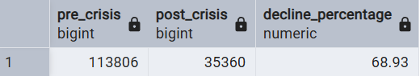

--Q2. Which top 5 city groups experienced the highest percentage decline in orders
--during the crisis period compared to the pre-crisis period?
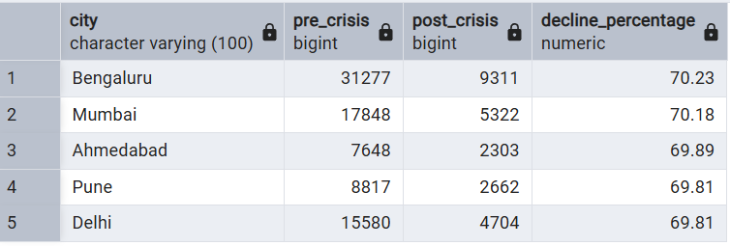

--Q3 Among restaurants with at least 50 pre-crisis orders, which top 10 high-volume
--restaurants experienced the largest percentage decline in order counts during
--the crisis period?

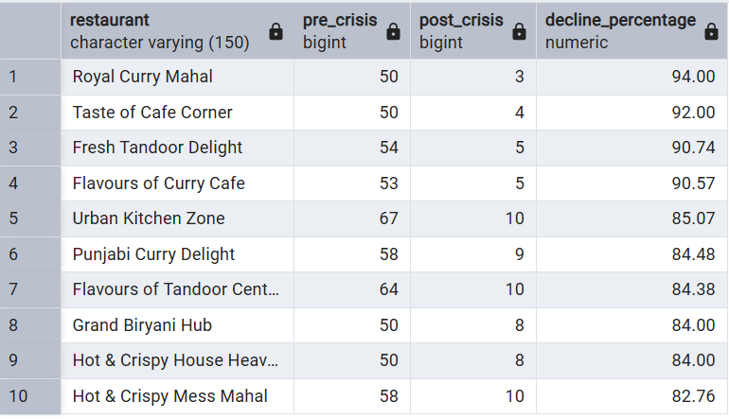

--Q4 Cancellation Analysis: What is the cancellation rate trend pre-crisis vs crisis,
--and which cities are most affected?
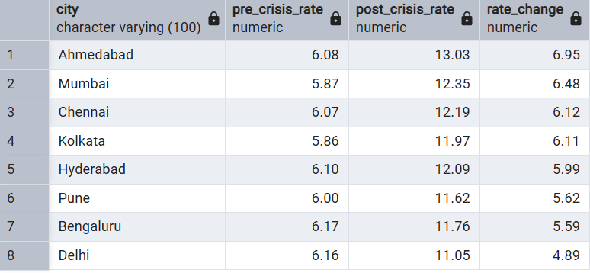

/*5. Delivery SLA: Measure average delivery time across phases. Did SLA
compliance worsen significantly in the crisis period?*/

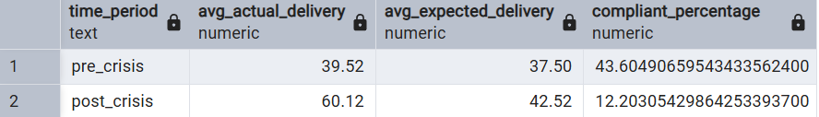

/*6. Ratings Fluctuation: Track average customer rating month-by-month. Which
months saw the sharpest drop?*/

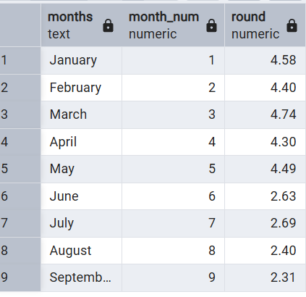
/*7. Sentiment Insights: During the crisis period, identify the most frequently
occurring negative keywords in customer review texts. (Hint: Use a Word Cloud
isual in Power BI to visualize the find*/

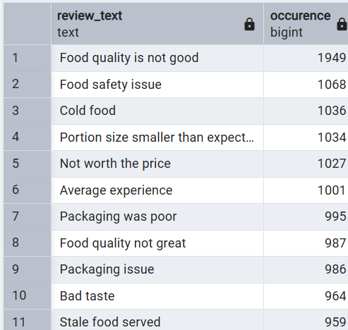
8.Revenue Impact: Estimate revenue loss from pre-crisis vs crisis (based on
subtotal, discount, and delivery fee).

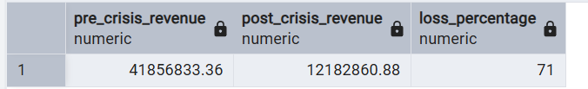
9. Loyalty Impact: Among customers who placed five or more orders before the
crisis, determine how many stopped ordering during the crisis, and out of those,
how many had an average rating above 4.5?

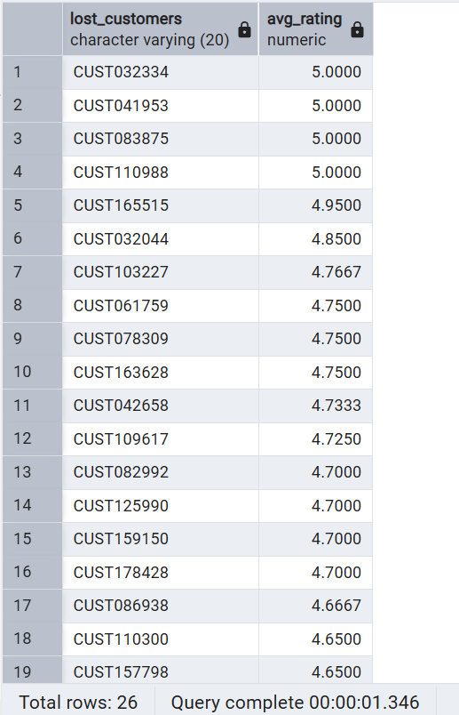

10. Customer Lifetime Decline: Which high-value customers (top 5% by total
spend before the crisis) showed the largest drop in order frequency and ratings
during the crisis? What common patterns (e.g., location, cuisine preference,
delivery delays) do they share?

